Will Rogers High School
Class of 1963
50th Reunion
May 10 – 11, 2013

Two Host Hotels have been reserved for our event
Fairfield Inn & Suites Marriott
111 North Main Street, Tulsa, Oklahoma 74103
For reservations call 918-879-1800
Our group rate per night: King $89.00 = Queen $99.00
Be sure to mention Will Rogers Class 63 Reunion
Limited rooms available: Cutoff Date: April 19, 2013

******************************************************************************

100 East Second Street, Tulsa, Oklahoma 74103
For reservations call 918-582-9000
Our group rate per night: King $99.00 = Queen $99.00
www.tulsa.hyatt.com
Limited rooms available: Cutoff Date: April 19, 2013
Be sure to mention Will Rogers Class 63 Reunion

If you have any problems with your registration please
Contact Dale Fenton Davis ASAP
918-576-1667 or verndale@sbcglobal.net

We begin down memory lane with our opening party

May 10th - Cain's Ballroom Denim & Diamonds – Dinner/Dance
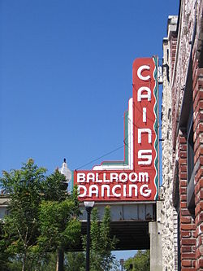
6:00 – 11:00 pm
Cain's Ballroom is a historic music venue in Tulsa built in 1924 to serve as a garage for one of Tulsa's founders, W. Tate Brady. Madison W. "Daddy" Cain purchased the building in 1930 and named it Cain's Dance Academy, where he charged 10¢ for dance lessons. The academy was the site of Bob Wills and His Texas Playboys first regular radio broadcast...

Catered Buffet dinner – Cash Bar - Dress: Casual
Music provided by DJ John, Broken Arrow Music DJ - www.bamusicdj.com

**********************************************************************************************************************
May 11 th – Assembly @ Will Rogers High School
8:00 a.m. Classic cars will be on display in the oval – Got one bring one!
Contact Mike Renfro @ 918-595-5411 or email mike@renfroassociates.com
9:00 a.m. School opens for self guided tours
10:00 – 11:45 a.m. ASSEMBLY IN AUDITORIUM
Entertainment will be the history of Will Rogers High School by Steve Wright. A Will Rogers impersonator, Andy Hogan. Flamenco guitarist (WRHS Class of 62), Ron (Hank) Radford.
**********************************************************************************************************************
May 11th - Dinner/Dance @ The Jazz Union Depot
7:00 - midnight
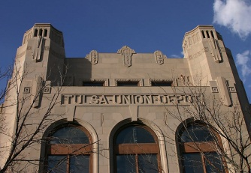
The Depot was built in 1931 in an Art-Deco style by the Public Works Administration and was considered the single best PWA symbol of hope for economic recovery during the bleak days of the depression. The Depot was the first central station in the city of Tulsa, and it unified the small Frisco, Katy, and Santa Fe depots. The Oklahoma Jazz Hall of Fame moved to the site in 2007 as part of the city's Vision 2025 program and is affectionately referred to as the “Jazz Depot”.

Catered Buffet dinner - Cash Bar - Dress: Men: Coat and Tie not required
Ladies: Dressy Casual to Cocktail -
Music performed by Easy Street Band

- Golf: Prior to Reunion
If interested, contact Larry Houston @ 918-688-1625 or lhouston@apb-bend.com

- A 50th Reunion Year book will be available for purchase at the reunion.

- (Ten) $100.00 gift cards – (five per night) will be given away via a random drawing. Must be present to win!

Donations to help offset expenses are welcomed.
Containers will be available each evening to receive your contributions.

Please review the Lost List on our website www.willrogers1963.com (Password is: wrhs1963)
Contact Pam Holland Thomas 925-462-6938 or bthom@sprynet.com with current information.

